**Kontakkt School ERP Teacher Module User Guide**

**Introduction**

Welcome to the Kontakkt School ERP Teacher Module! This guide will help you navigate and utilize the various features and tools available in the teacher module.

**Accessing the Teacher Module**

**How do I log in to the Teacher Module?**

1. Go to the Kontakkt School ERP login page.
2. Enter your username and password.
3. Click on the "Login" button to access the student module.

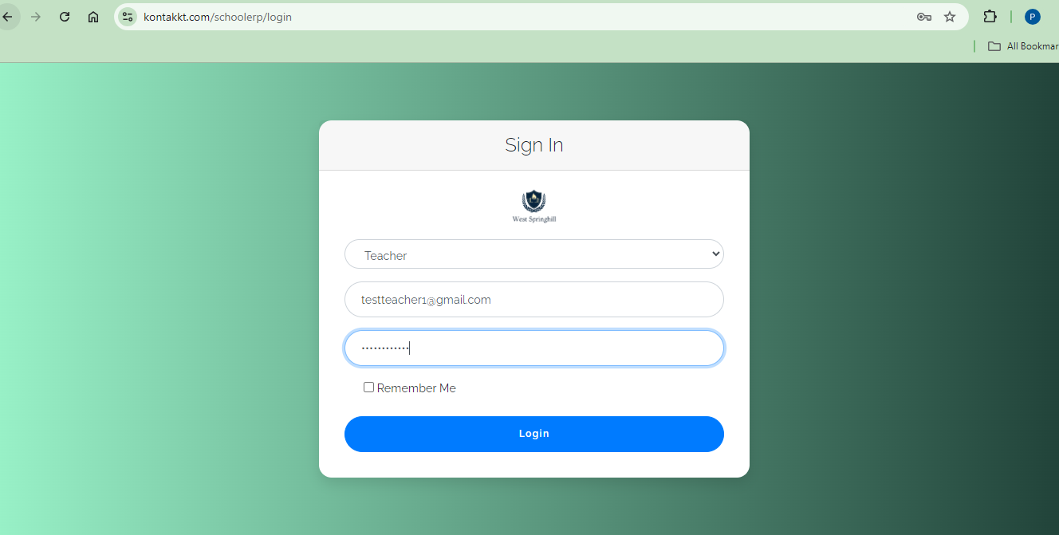

**Teacher** **Module Overview**

**What will I see upon logging in?**

Upon logging in, you will be greeted with the main dashboard interface divided into several sections.

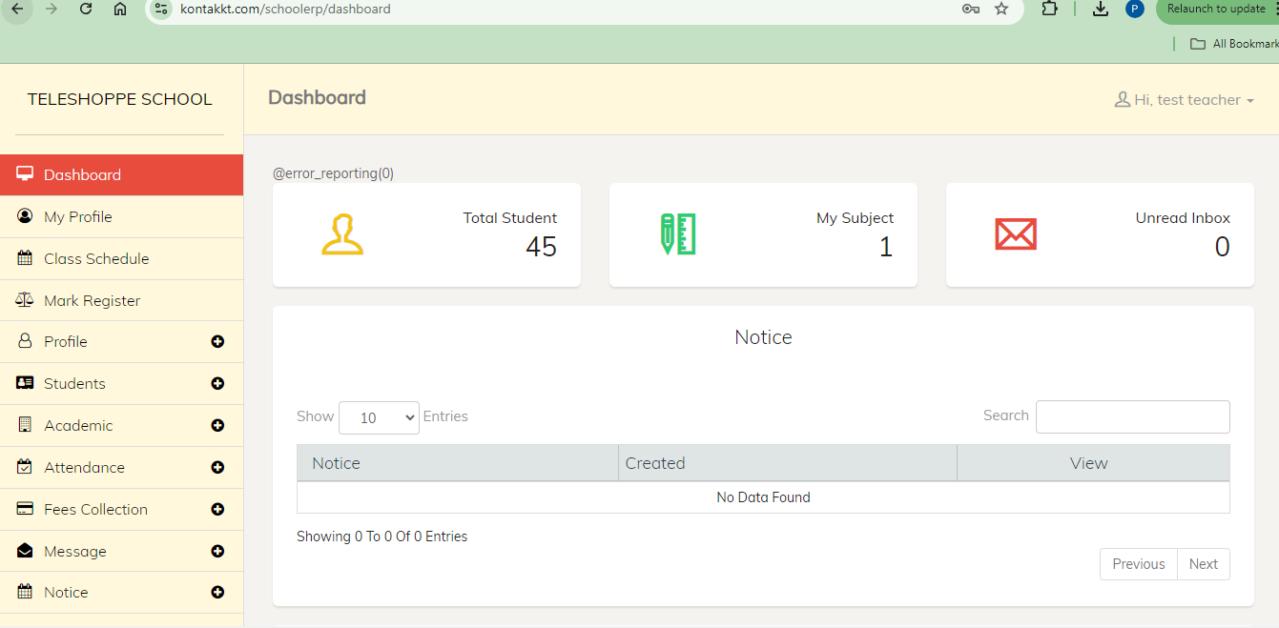

**Navigation Menu**

The navigation menu on the left side provides quick access to different student related features:

* **Dashboard**: Returns you to the main dashboard view.

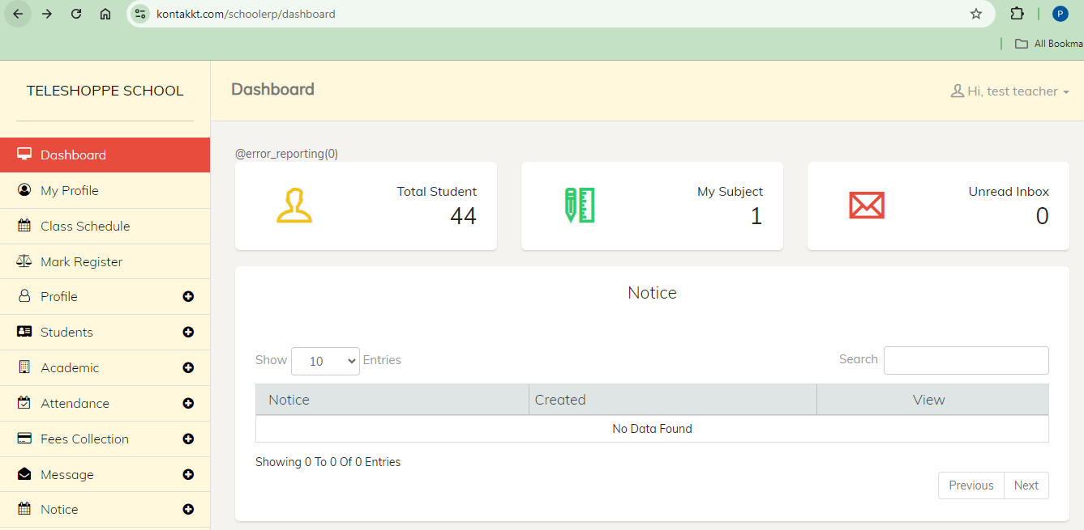

* **My Profile**: View and edit your personal information.

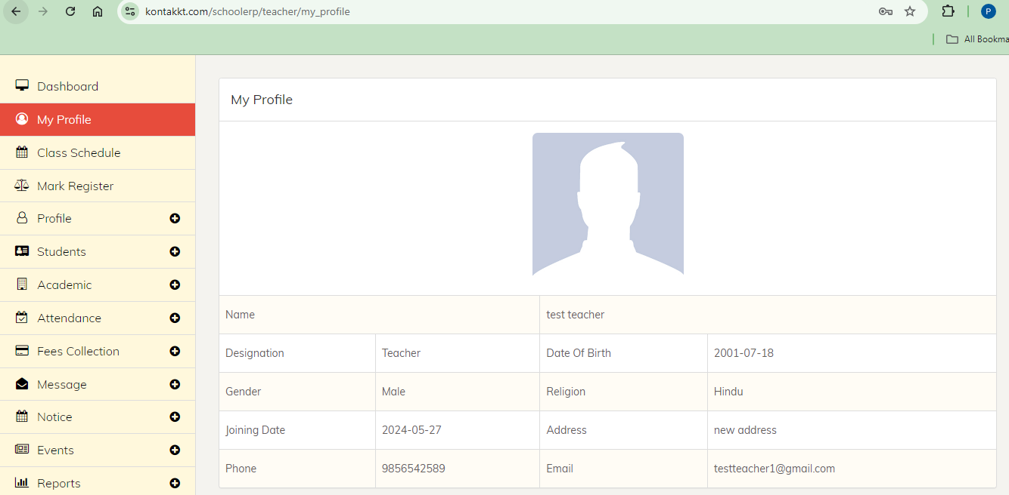

* **Class Schedule:**  View and manage class schedules and assignments.

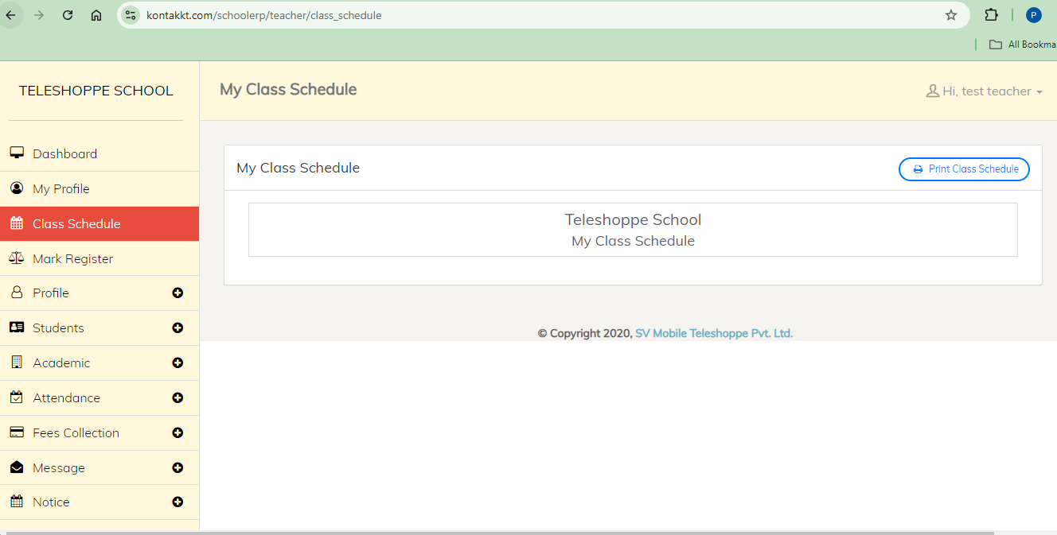

* **Mark Register**: View, record and manage student marks effectively.

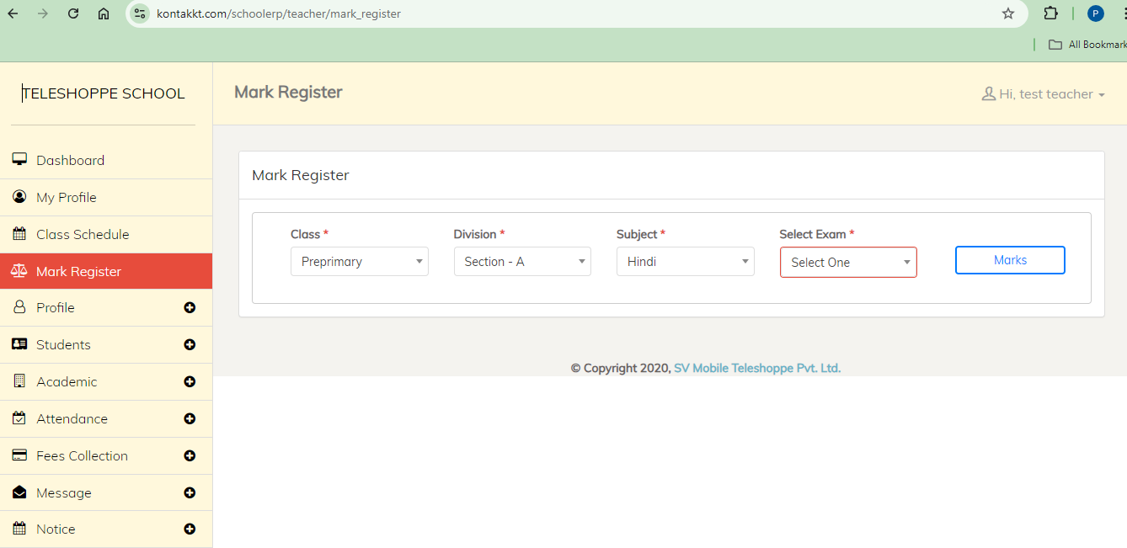

* **Students**: View and manage information about students effectively.

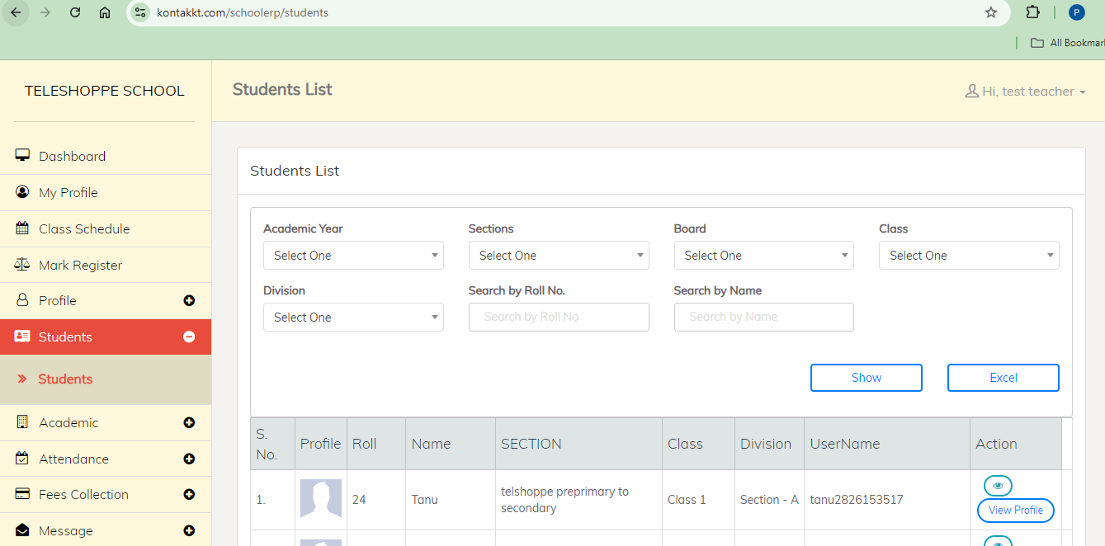

* **Academic**: Create, manage, and monitor homework assignments for your students effectively.

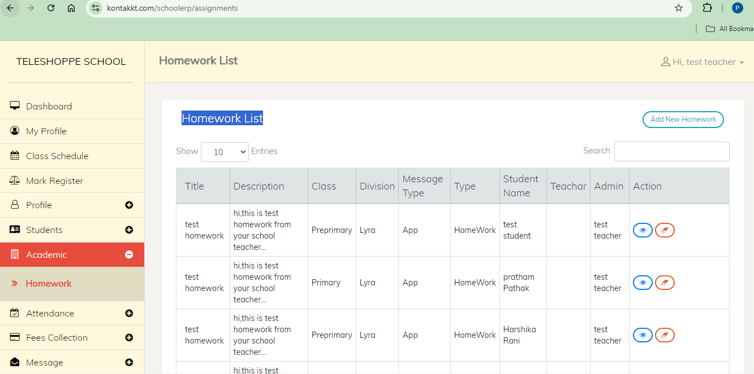

* **Attendance:** Record, manage, and monitor student attendance effectively.

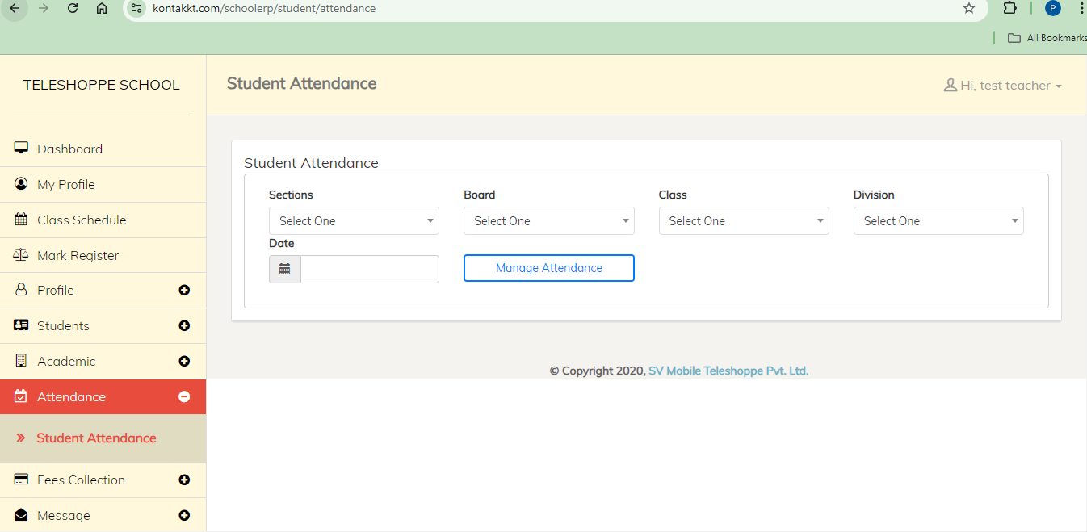

* **Fees Collection**: View, manage and monitor student fees effectively.

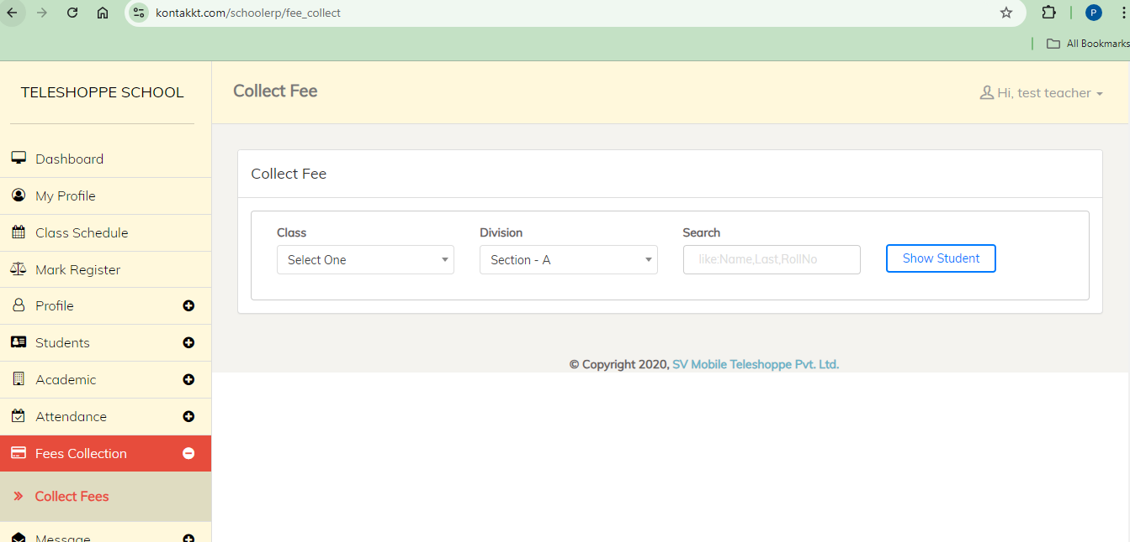

* **Notice**: Manage, issue important communications to students, parents, and staff

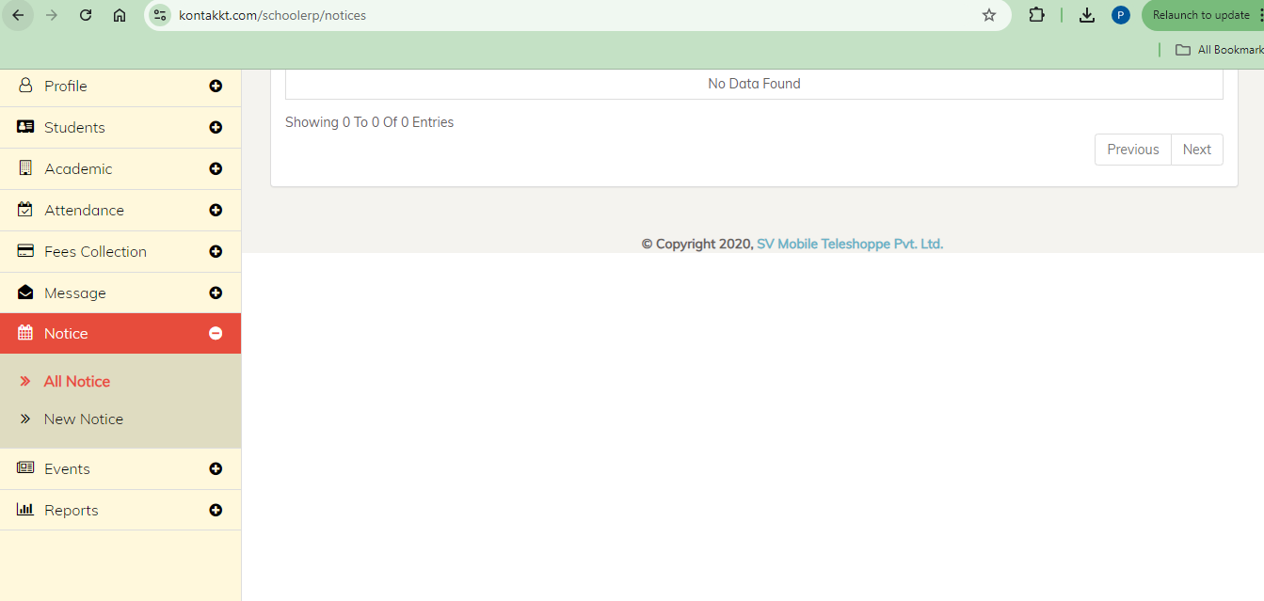

* **Event**: View and manage various events such as academic conferences, extracurricular activities, and faculty meetings.

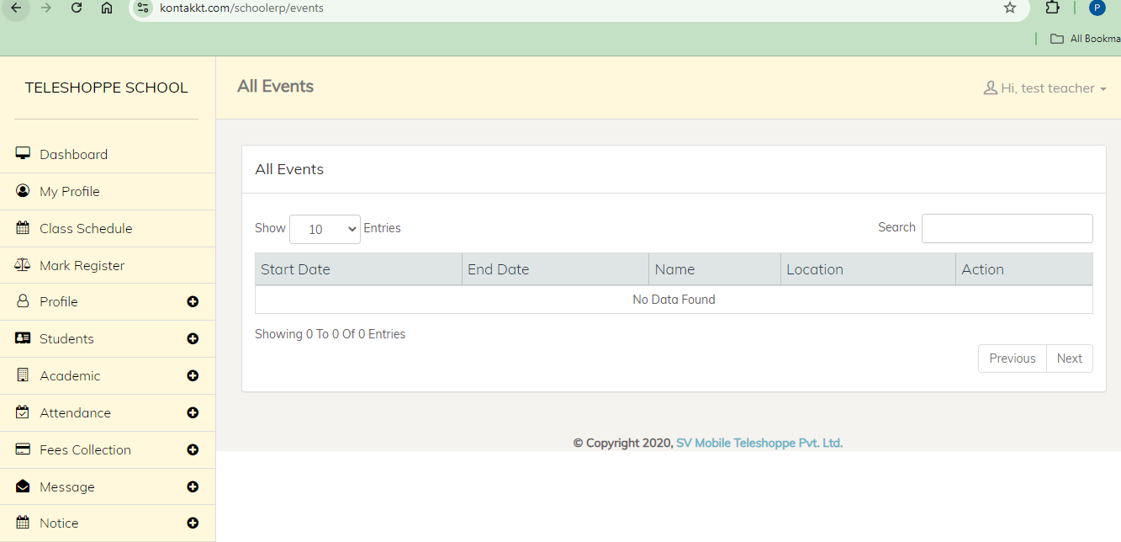

* **Reports**: Generate report related to student attendance.

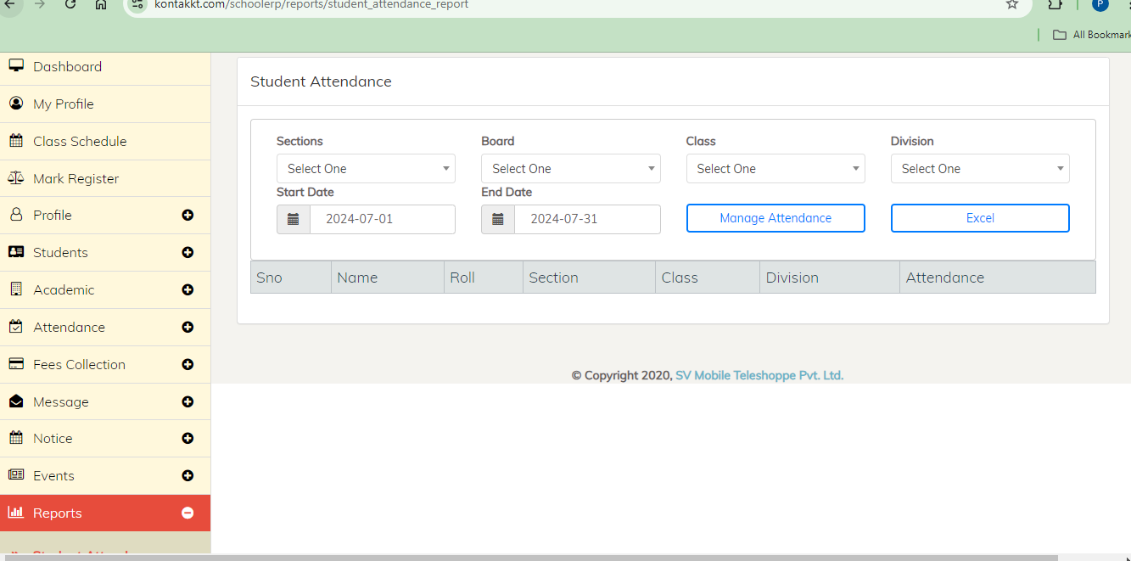

**Main Dashboard Area**

The central part of the dashboard displays an overview of key metrics and recent activities:

* **Statistics**: Quick stats on total students, my subjects, unread messages, notices.
* **Recent Activities**: Latest updates and activities within the system.
* **Notifications**: Important notifications and alerts.

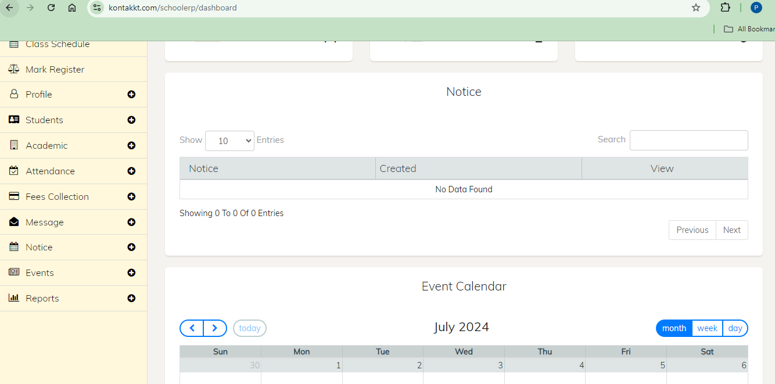

**Top Bar**

The top bar provides quick access to user profile settings, notifications, and help:

* **User Profile**: Click to view and edit your profile information.
* **Change Password**: Click to change your password.
* **Logout**: Click to logout from the application.

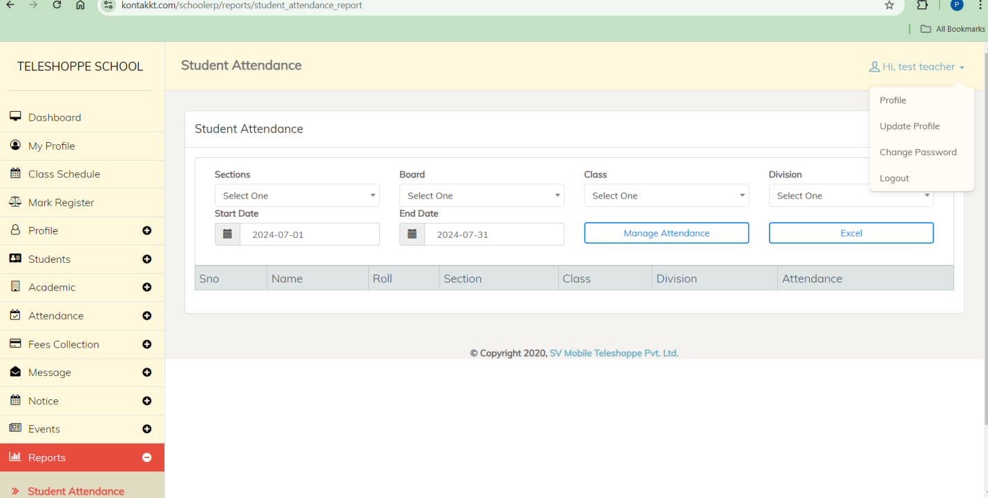

**Using the Teacher Module Features**

**Q: How do I manage my profile?**

**A: Click on Profile Section**

1. Click on the "Update Profile".
2. View your personal information.
3. Update your information.
4. Click on the "Update Profile".

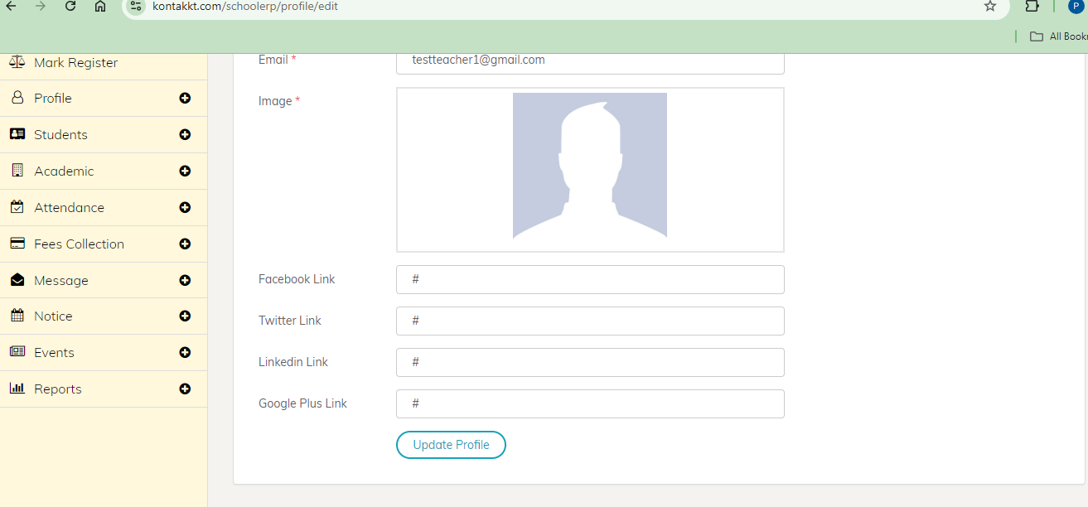

**Q: How do I change my password?**

**A: Click on Profile Section**

1. Click on the "Change Password".
2. Change your password.
3. Click on the "Update Password ".

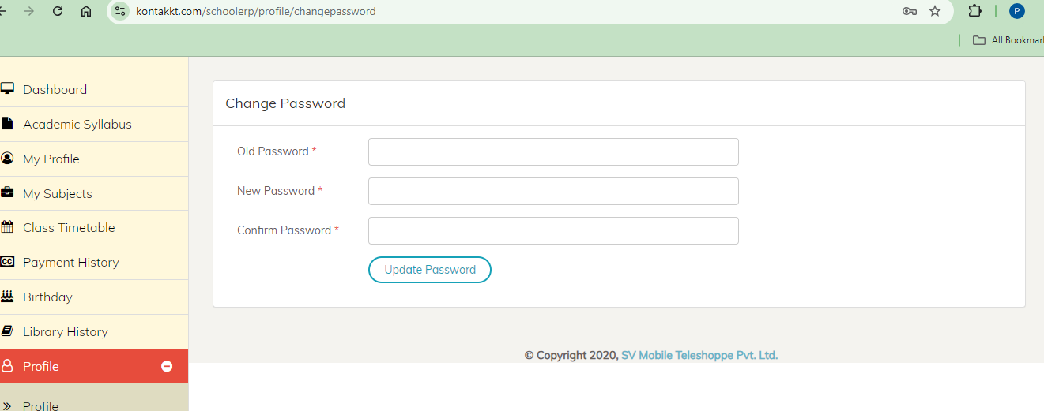

**Q: How do I view student records?**

**A: Click on Students section**

1. Click on the “Students ".
2. Select category and provide required details.
3. Click on the “Show ".

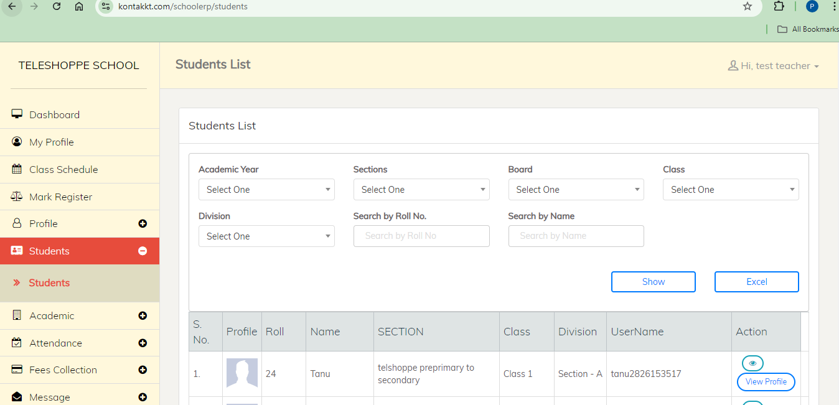

**Q: How do I add homework?**

**A: Click on Academic section**

1. Click on the "Add New Homework".
2. Select category and provide required details
3. Click on the “Add Homework ".

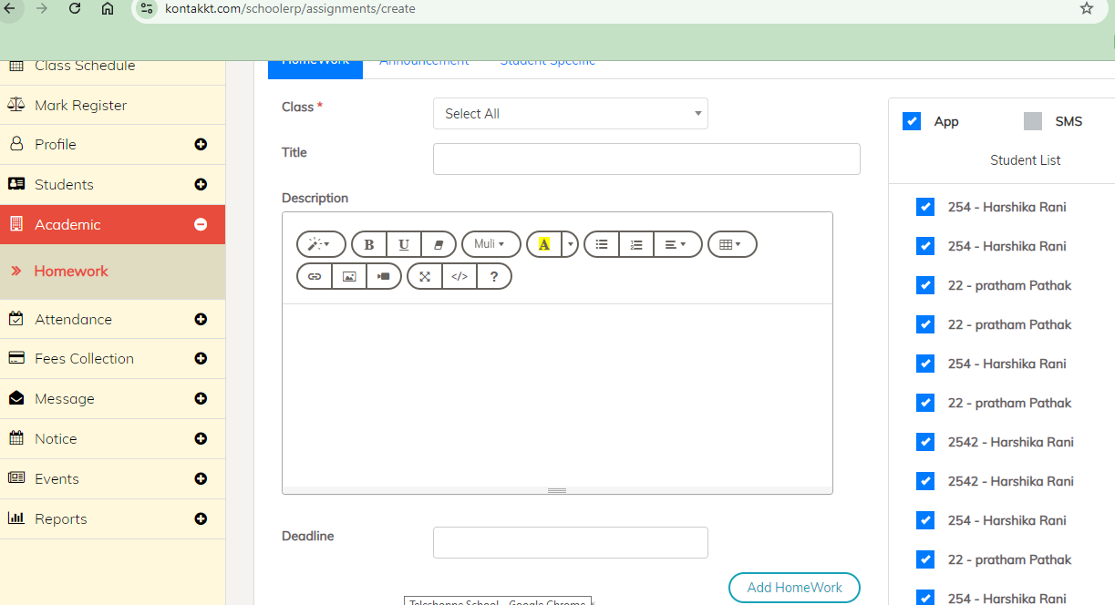

**Q: How do I create notice?**

**A: Click on Notice section**

1. Click on the "New Notice".
2. Provide the required details.
3. Click on the “Save ".

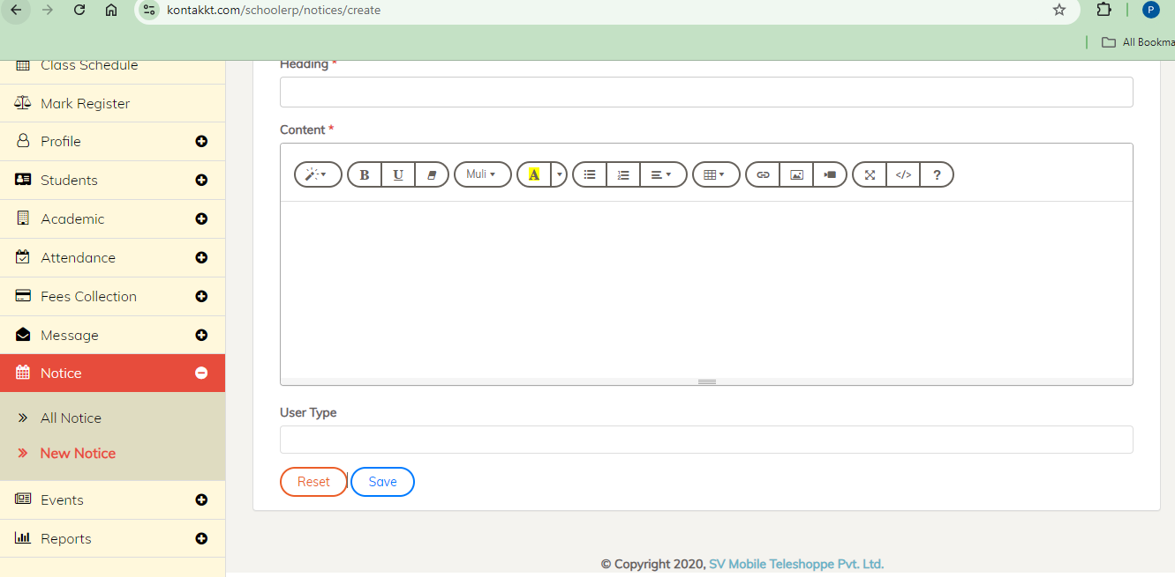

**Q: How do I create message?**

**A: Click on Message Section**

1. Click on the "New Message".
2. Fill the required details.
3. Click on the "Send Message".

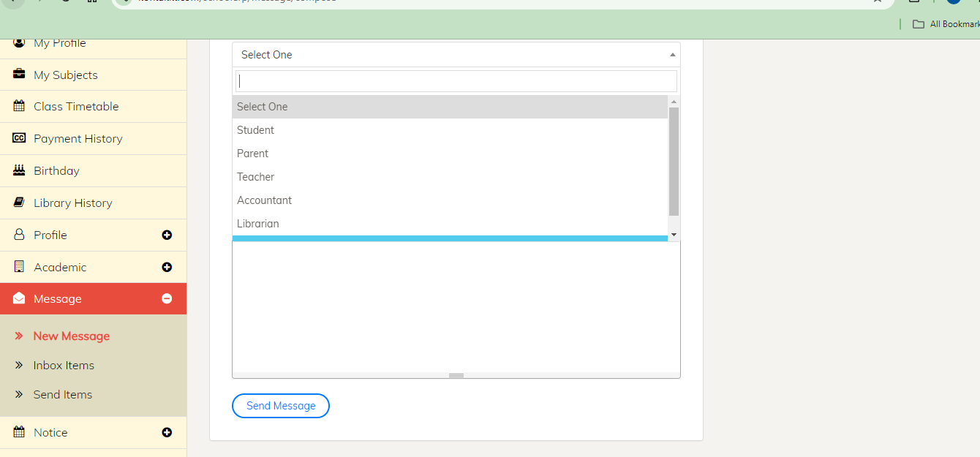

**Q: How do I check my messages?**

**A: Click on Message Section**

1. Click on the "Inbox Items".
2. View messages.

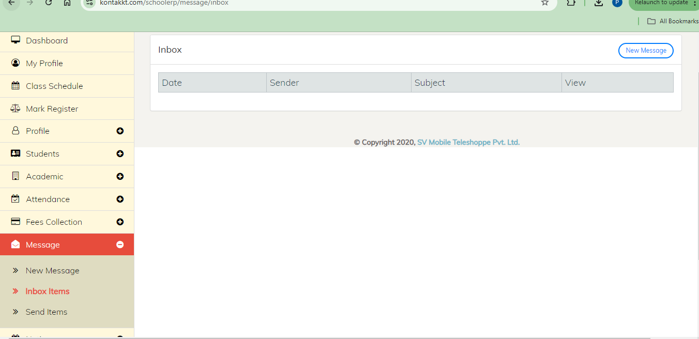

**Getting Help**

**What if I encounter any issues or need assistance?**

If you encounter any issues or need assistance, you can access the help resources by clicking on the "Help" option in the top bar or contacting Kontakkt support.