**Kontakkt School ERP Student Module User Guide**

**Introduction**

Welcome to the Kontakkt School ERP Student Module! This guide will help you navigate and utilize the various features and tools available in the student module.

**Accessing the Student Module**

**How do I log in to the Student Module?**

1. Go to the Kontakkt School ERP login page.
2. Enter your username and password.
3. Click on the "Login" button to access the student module.

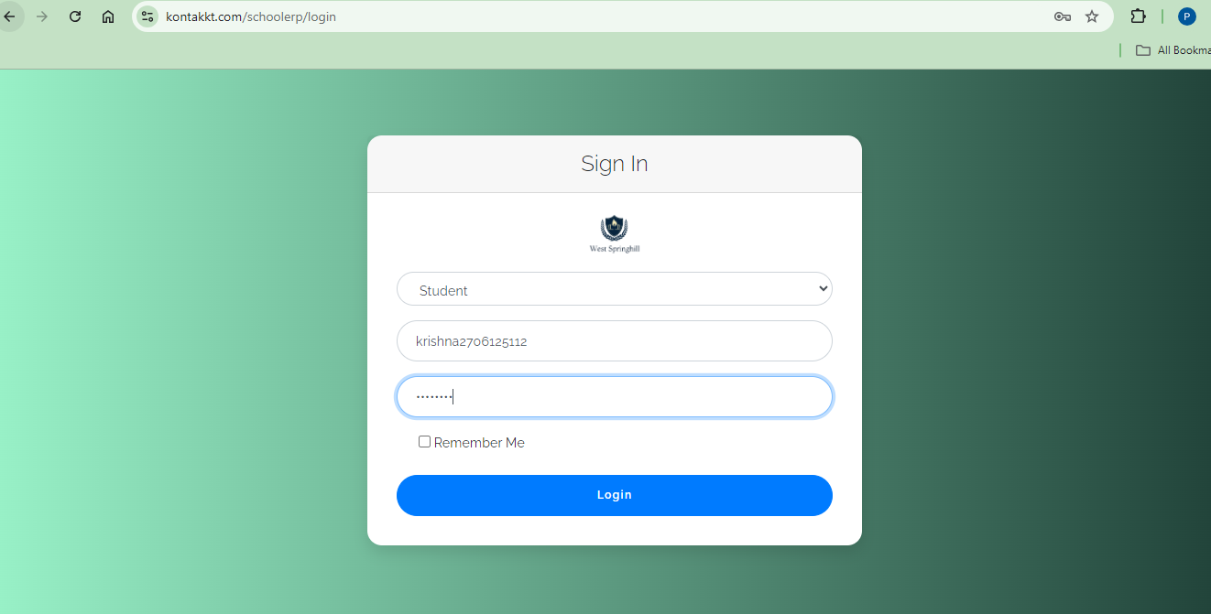

**Student Module Overview**

**What will I see upon logging in?**

Upon logging in, you will be greeted with the main dashboard interface divided into several sections.

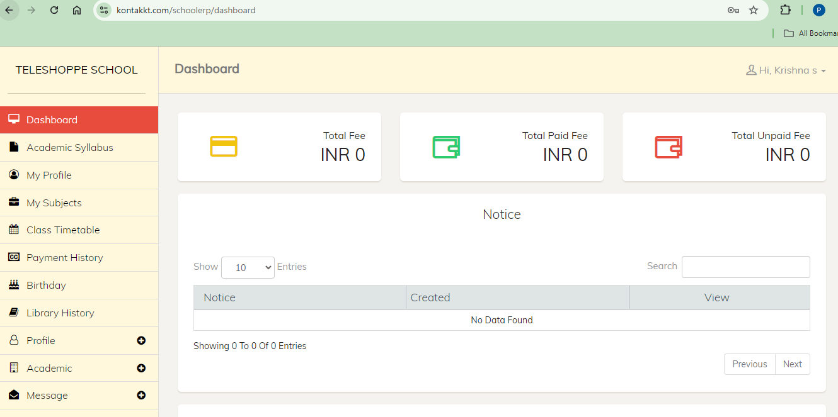

**Navigation Menu**

The navigation menu on the left side provides quick access to different student related features:

* **Dashboard**: Returns you to the main dashboard view.



* **My Profile**: View and edit your personal information.

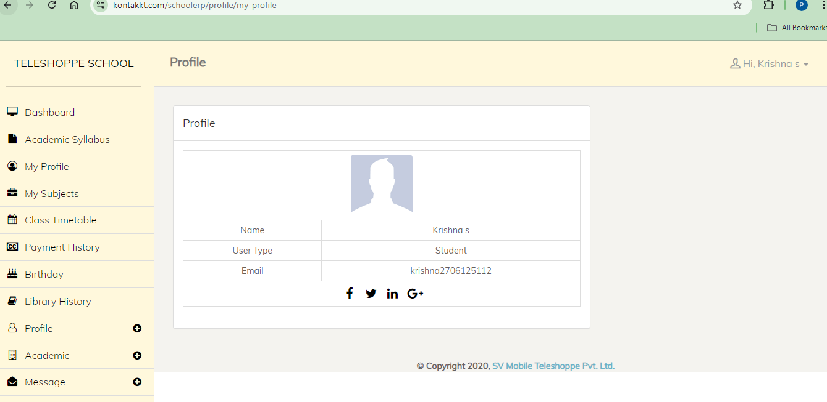

* **Syllabus**: Check the syllabus section for the entire details of syllabus, any updates or changes in the syllabus.

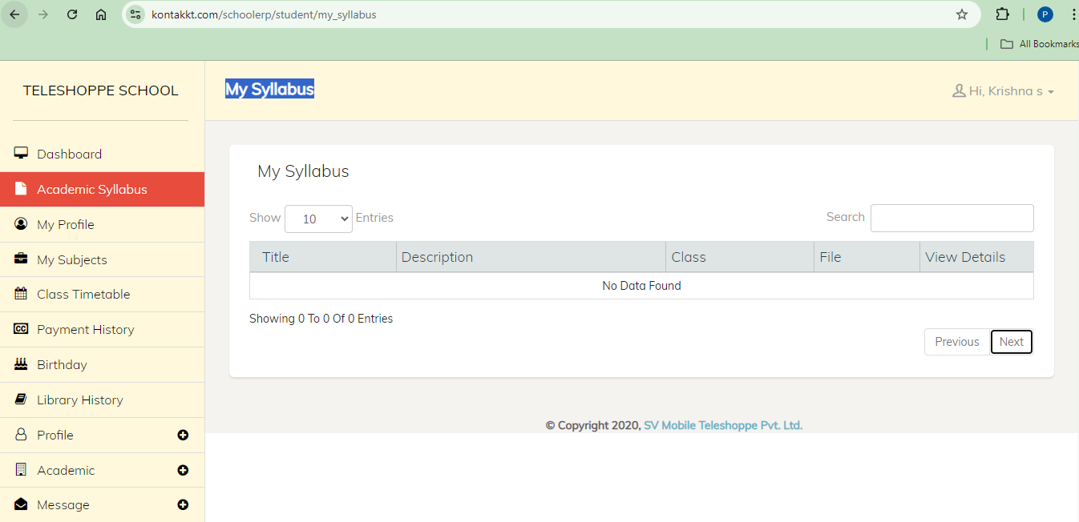

* **Subjects**: View a complete list of all subjects you are enrolled in for the academic year.

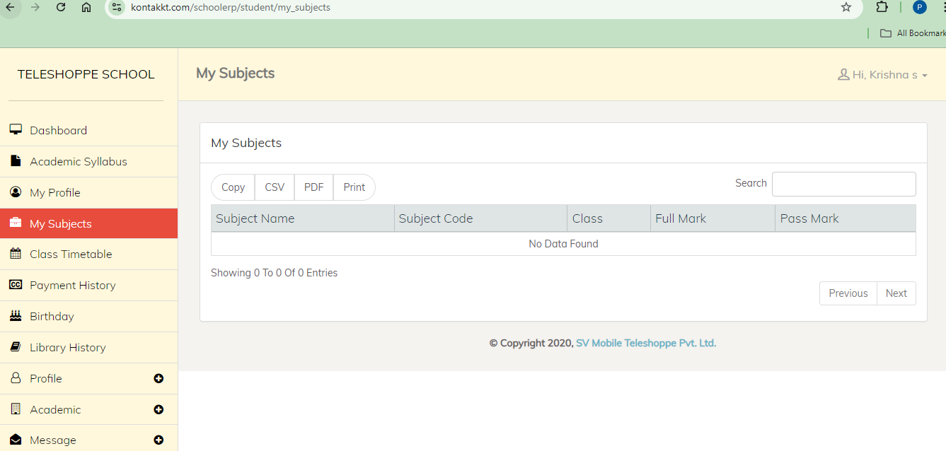

* **Exams**: View and manage your class timetable efficiently.

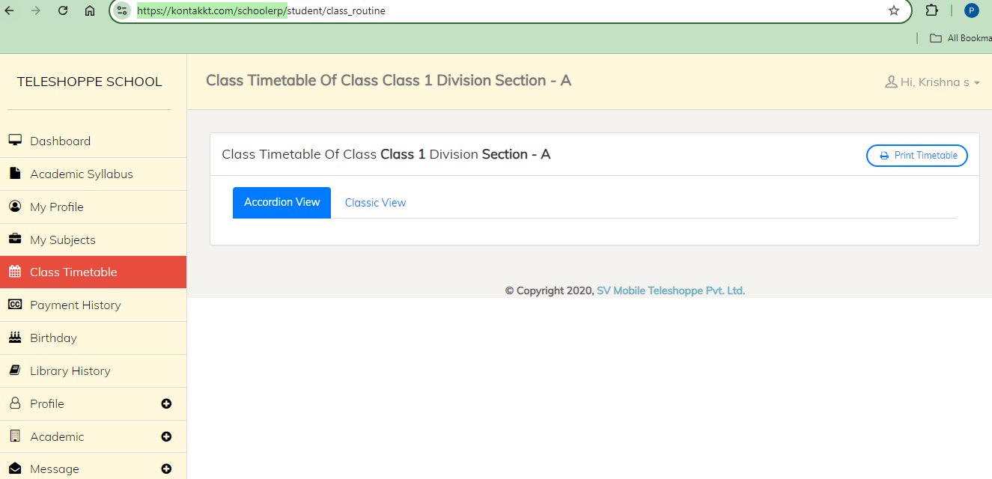

* **Payment History**: Comprehensive view of all your past payments.

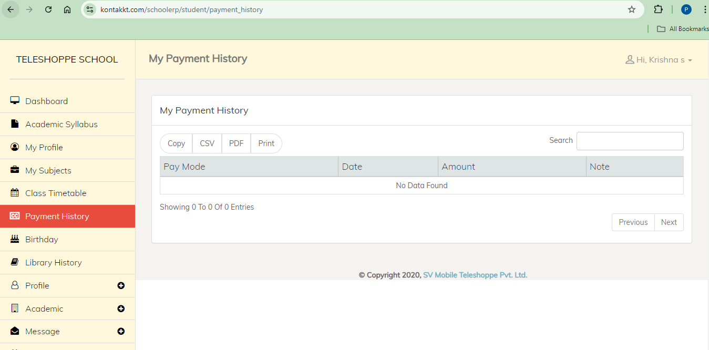

* **Birthday**: View a list of individuals celebrating their birthdays today, including both students and teachers.

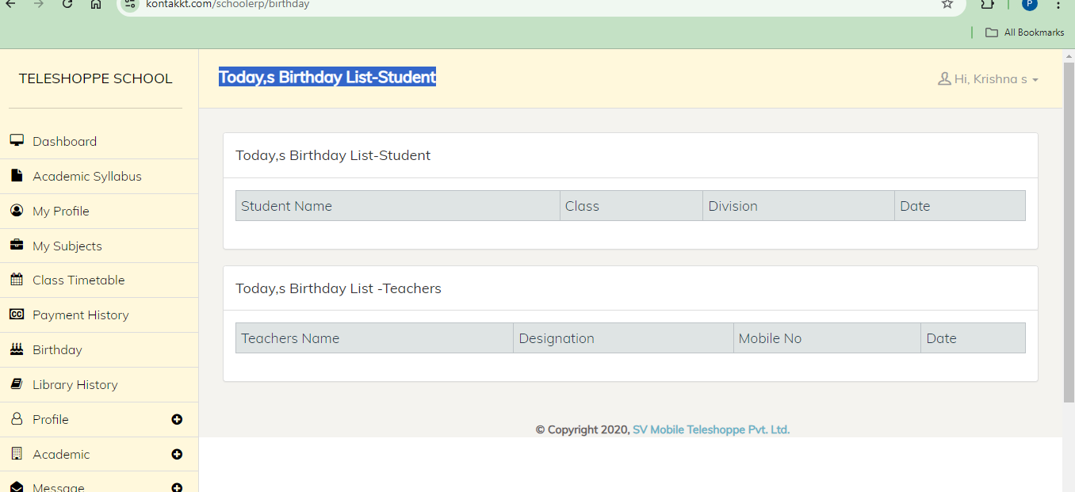

* **Library History**: View your borrowing history, including details of books you have borrowed from the library.

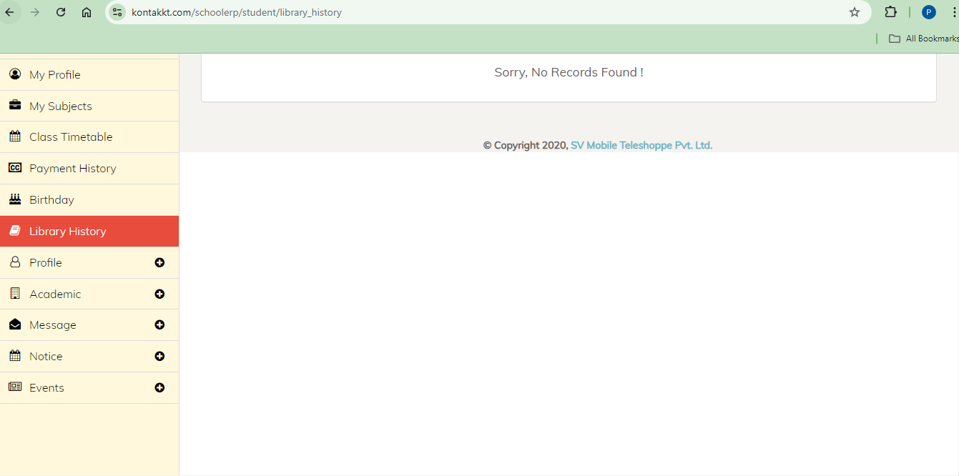

* **Events**: Events organized within the school, including academic, extracurricular, and special events.

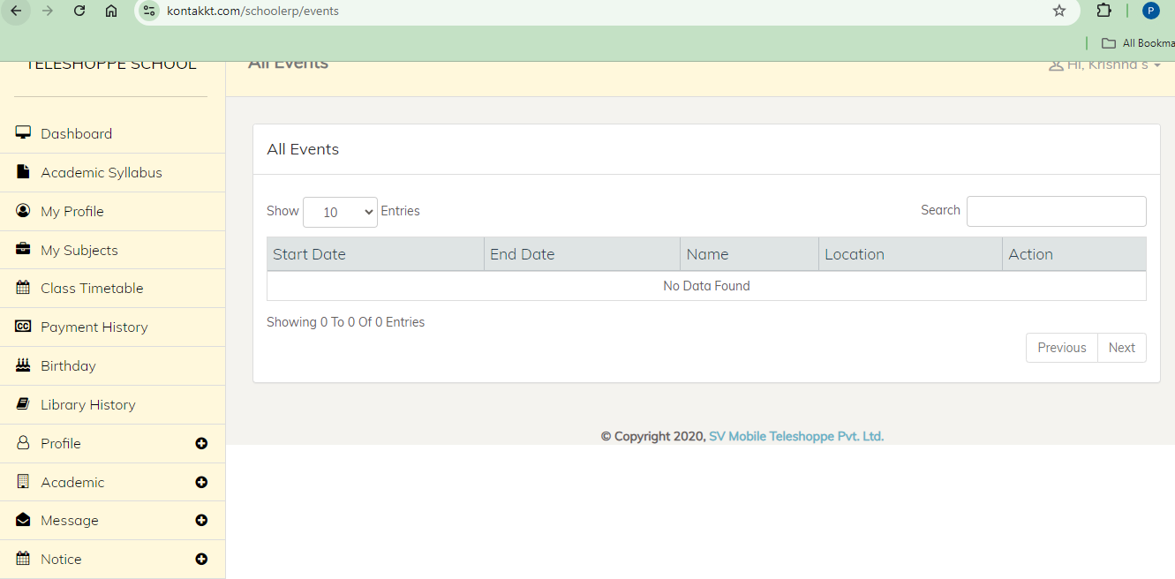

**Main Dashboard Area**

The central part of the dashboard displays an overview of key metrics and recent activities:

* **Statistics**: Quick stats on your total fee, total unpaid fee, and total paid fee, notices.
* **Recent Activities**: Latest updates and activities within the system.
* **Notifications**: Important notifications and alerts.

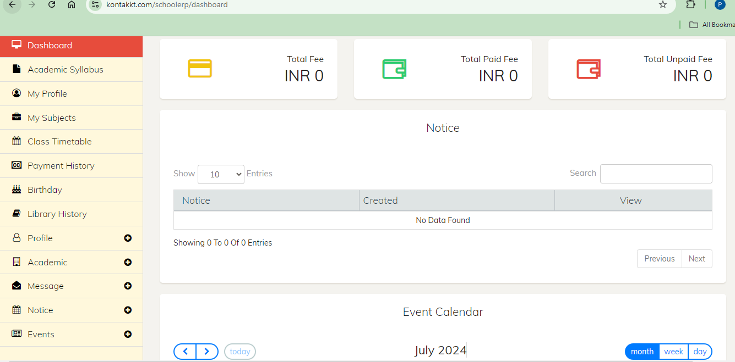

**Top Bar**

The top bar provides quick access to user profile settings, notifications, and help:

* **User Profile**: Click to view and edit your profile information.
* **Change Password**: Click to change your password.
* **Logout**: Click to logout from the application.

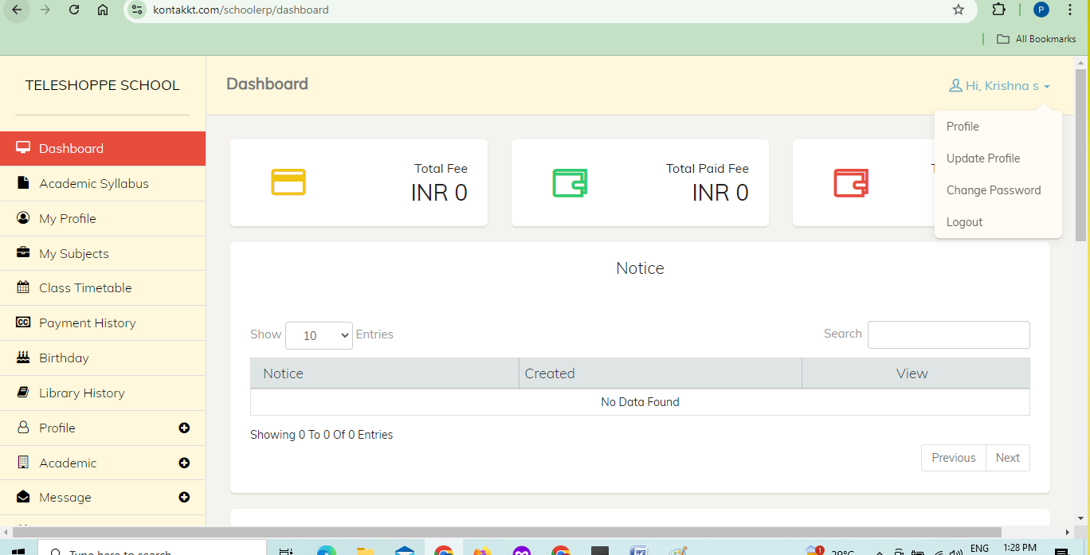

**Using the Student Module Features**

**Q: How do I manage my profile?**

**A: Click on Profile Section**

1. Click on the "Update Profile".
2. View your personal information.
3. Update your information.
4. Click on the "Update Profile".

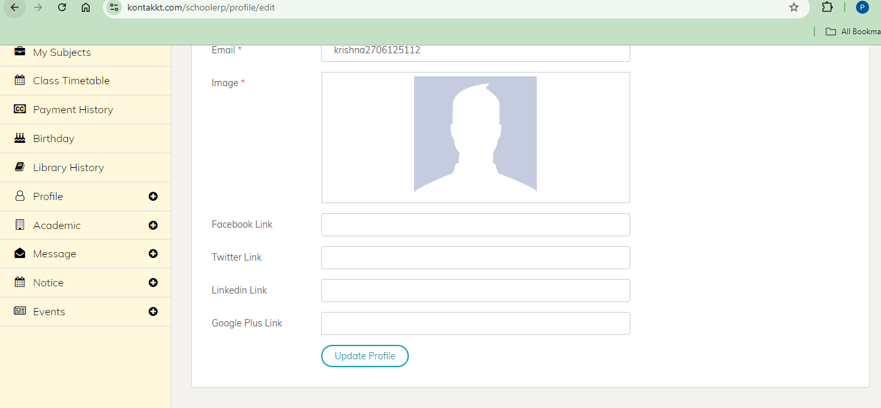

**Q: How do I change my password?**

**A: Click on Profile Section**

1. Click on the "Change Password".
2. Change your password.
3. Click on the "Update Password ".

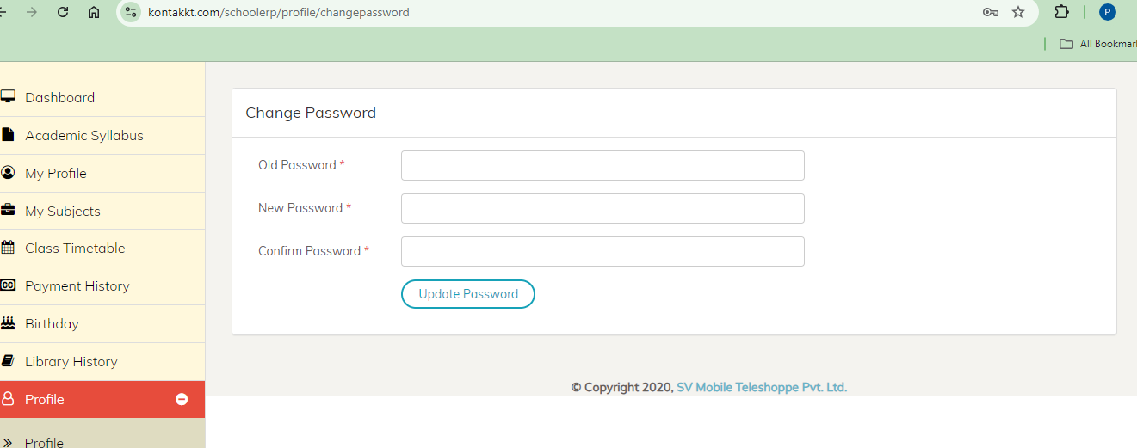

**Q: How do I send a mew message?**

**A: Click on Message Section**

1. Click on the "New Message".
2. Fill the required details.
3. Click on the "Send Message".

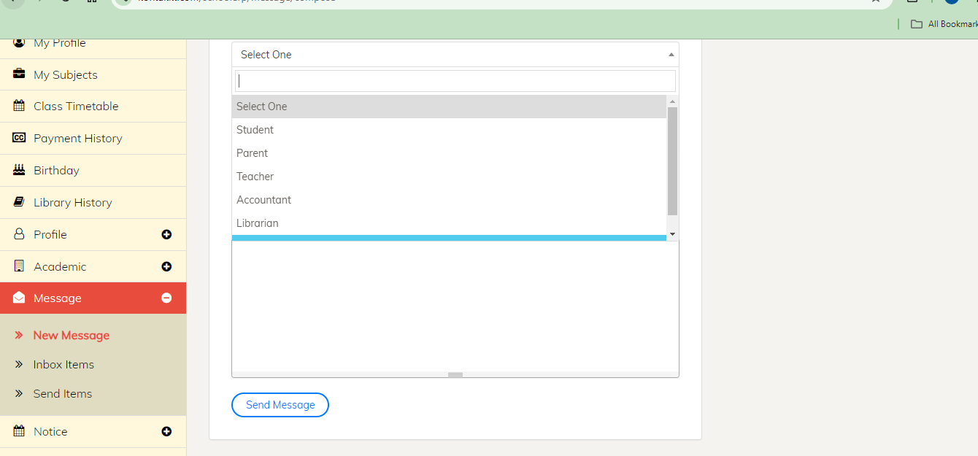

**Q: How do I check my received messages?**

**A: Click on Message Section**

1. Click on the "Inbox Items".
2. View messages.

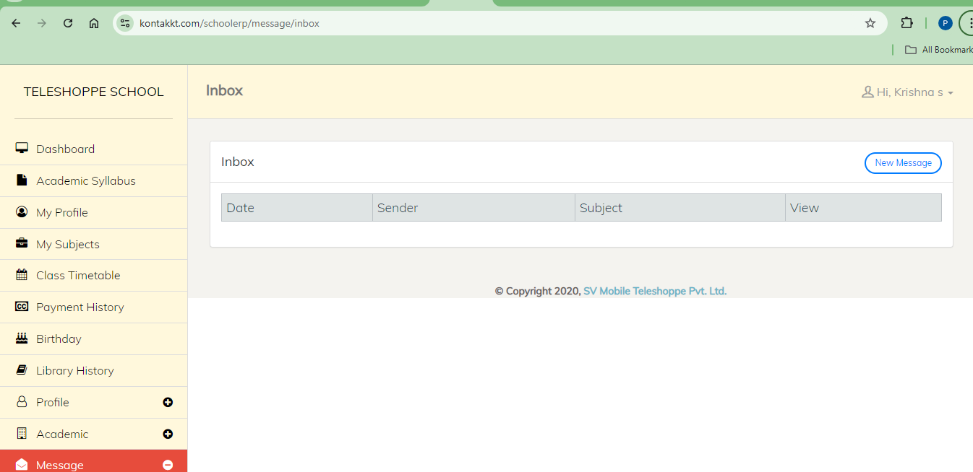

**Q: How do I check my sent messages?**

**A: Click on Message Section**

1. Click on the "Send Items".
2. View messages.

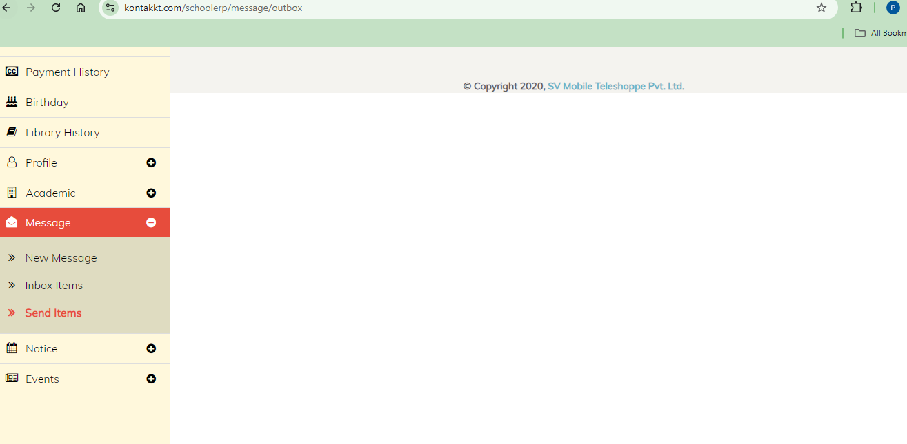

**Getting Help**

**What if I encounter any issues or need assistance?**

If you encounter any issues or need assistance, you can access the help resources by clicking on the "Help" option in the top bar or contacting Kontakkt support.