**Kontakkt School ERP Parent Module User Guide**

**Introduction**

Welcome to the Kontakkt School ERP Parent Module! This guide will help you navigate and utilize the various features and tools available in the parent module.

**Accessing the Parent Module**

**How do I log in to the Parent Module?**

1. Go to the Kontakkt School ERP login page.
2. Enter your username and password.
3. Click on the "Login" button to access the student module.

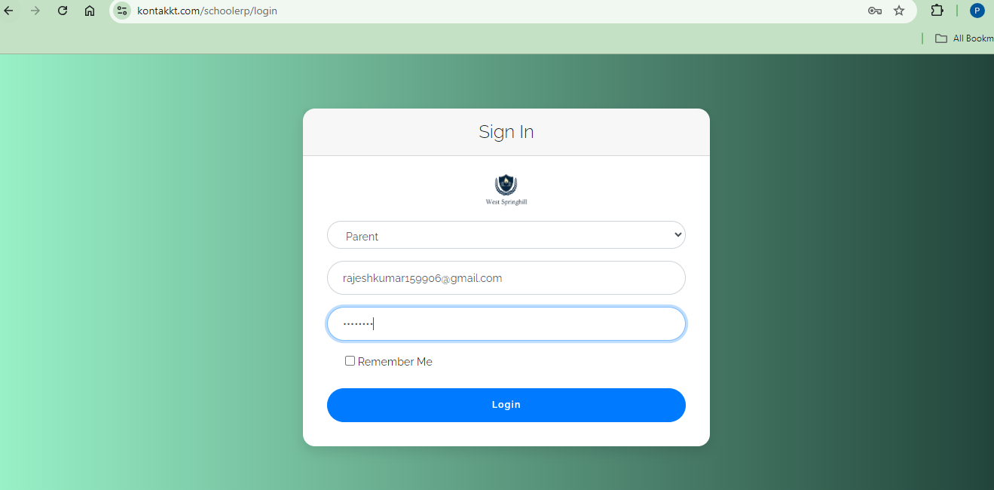

**Teacher** **Module Overview**

**What will I see upon logging in?**

Upon logging in, you will be greeted with the main dashboard interface divided into several sections.

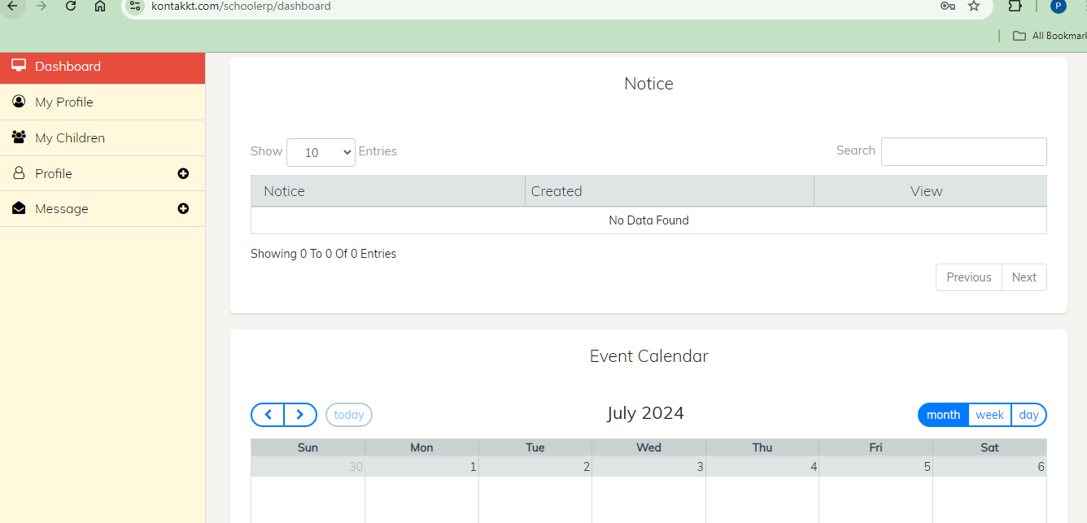

**Navigation Menu**

The navigation menu on the left side provides quick access to different parent related features:

* **Dashboard**: Returns you to the main dashboard view.

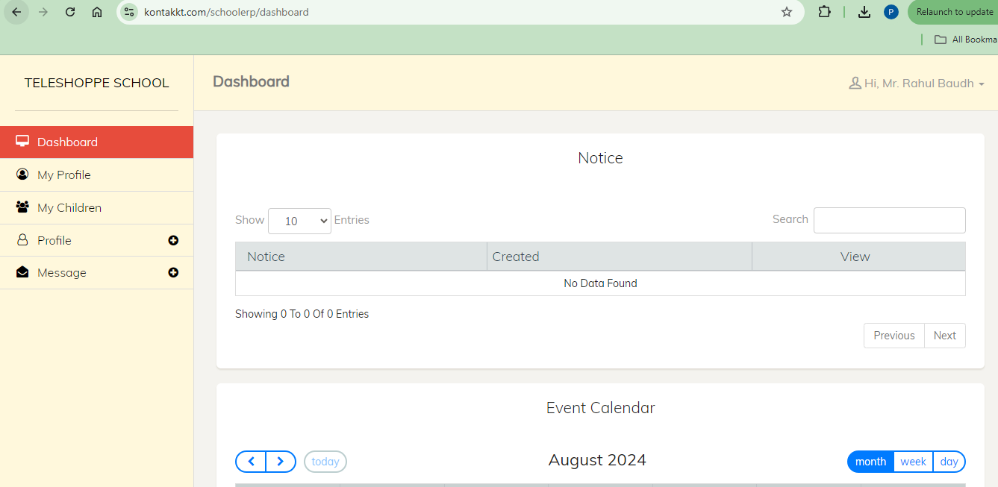

* **My Profile**: View and edit your personal information.

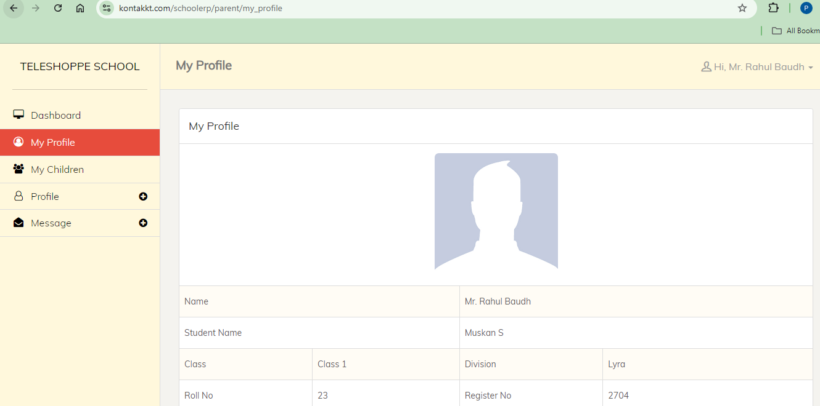

* **My Children:**  View and manage profile, attendance, progress card, fees.

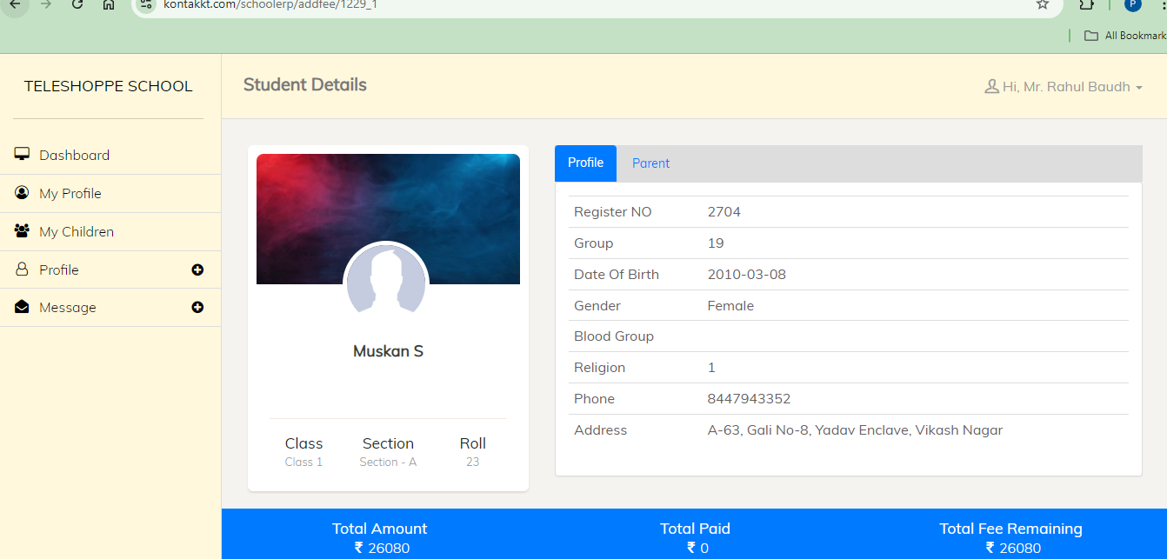

**Main Dashboard Area**

The central part of the dashboard displays an overview of key metrics and recent activities:

* **Statistics**: Quick updates on notice, events.
* **Recent Activities**: Latest updates and activities within the system.
* **Notifications**: Important notifications and alerts.

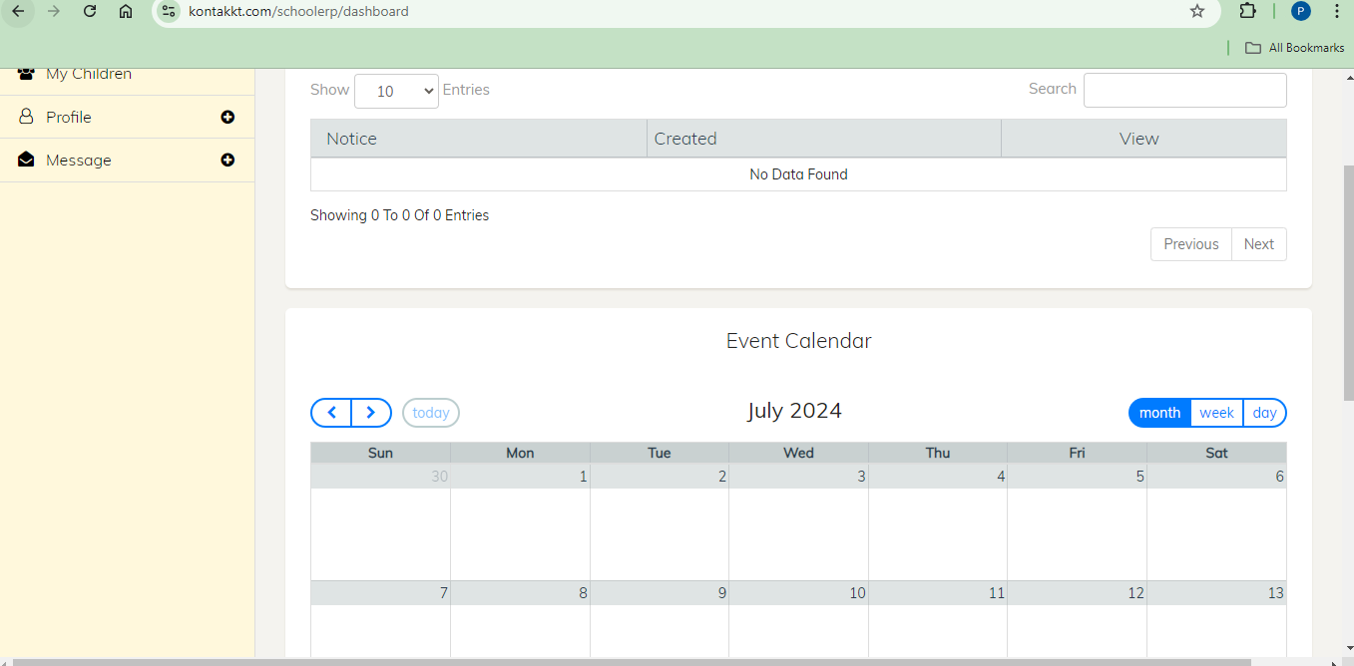

**Top Bar**

The top bar provides quick access to user profile settings, notifications, and help:

* **User Profile**: Click to view and edit your profile information.
* **Change Password**: Click to change your password.
* **Logout**: Click to logout from the application.

**Using the Parent Module Features**

**Q: How do I manage my profile?**

**A: Click on Profile Section**

1. Click on the "Update Profile".
2. View your personal information.
3. Update your information.
4. Click on the "Update Profile".

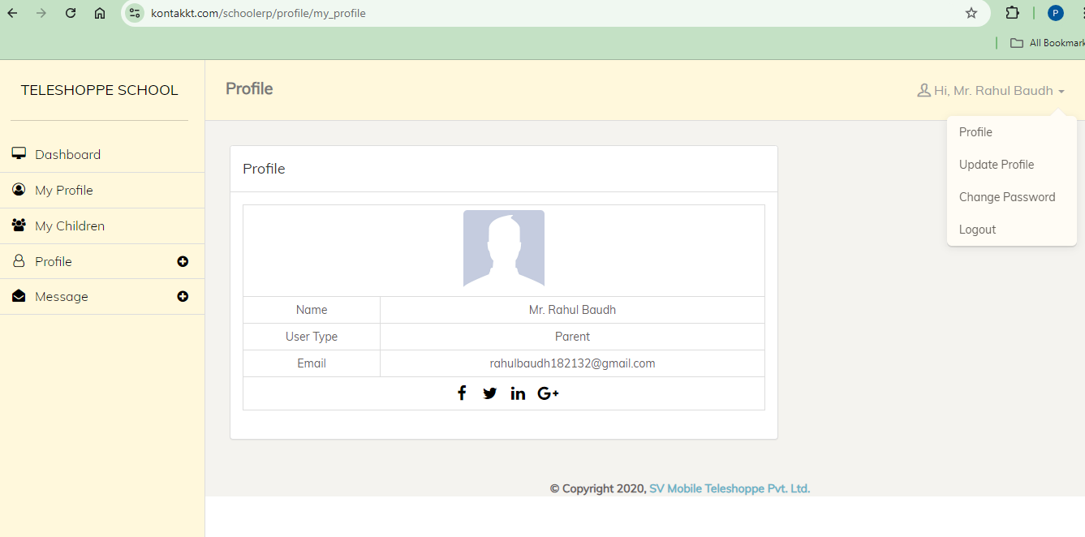

**Q: How do I change my password?**

**A: Click on Profile Section**

1. Click on the "Change Password".
2. Change your password.
3. Click on the "Update Password ".

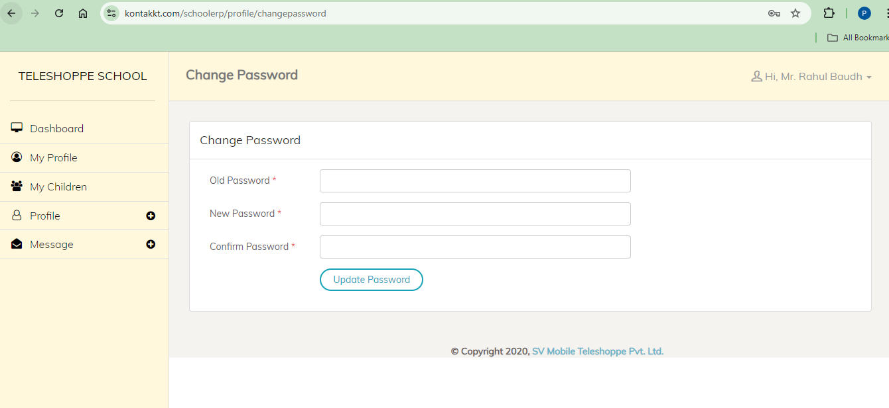

**Q: How do I view children attendance?**

**A: Click on My children section**

1. Click on the “Attendance ".
2. Select month
3. Click on the “View Attendance ".

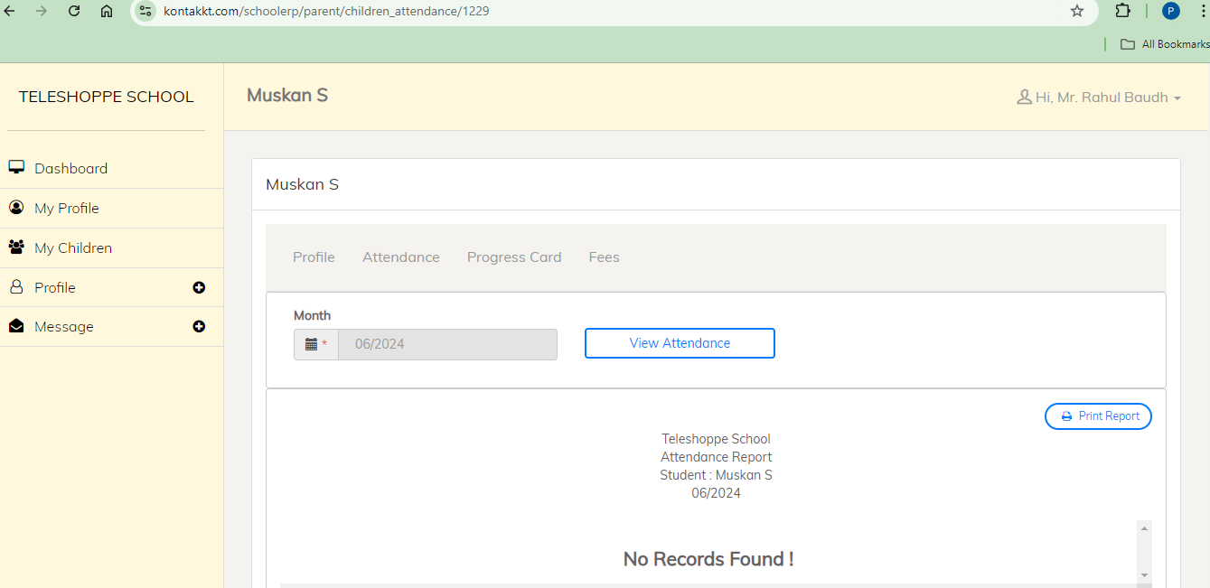

**Q: How do I check children progress card?**

**A: Click on My Children section**

1. Click on the “Progress Card".

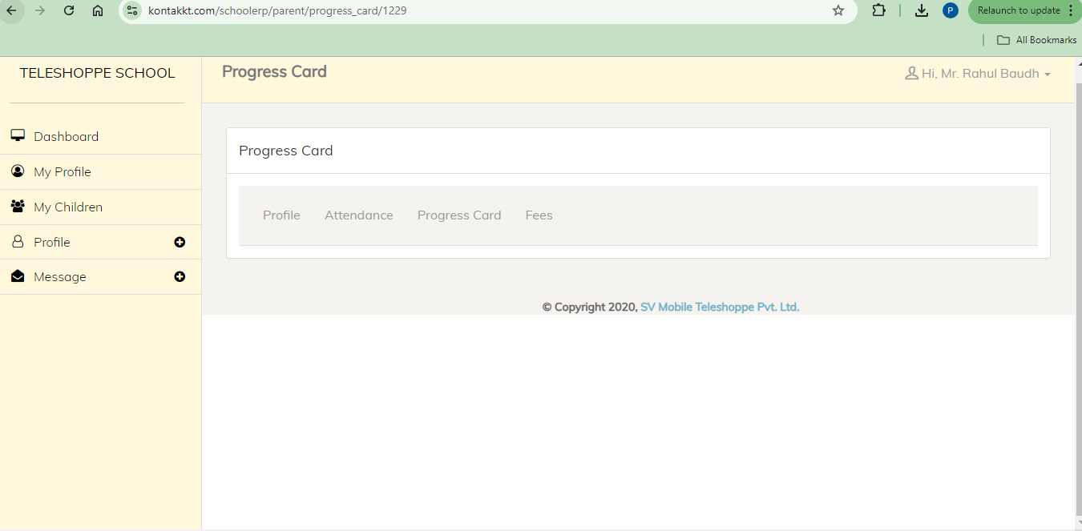

**Q: How do I check fees history and all the details?**

**A: Click on My Children section**

1. Click on the "Fees".

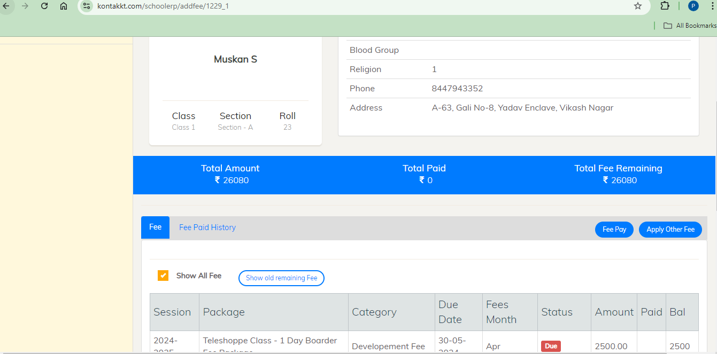

**Q: How do I pay the fees?**

**A: Click on My children section**

1. Click on the “Fees ".
2. Click on the “Fees Pay".
3. Provide all the details.
4. Click on “Save”.

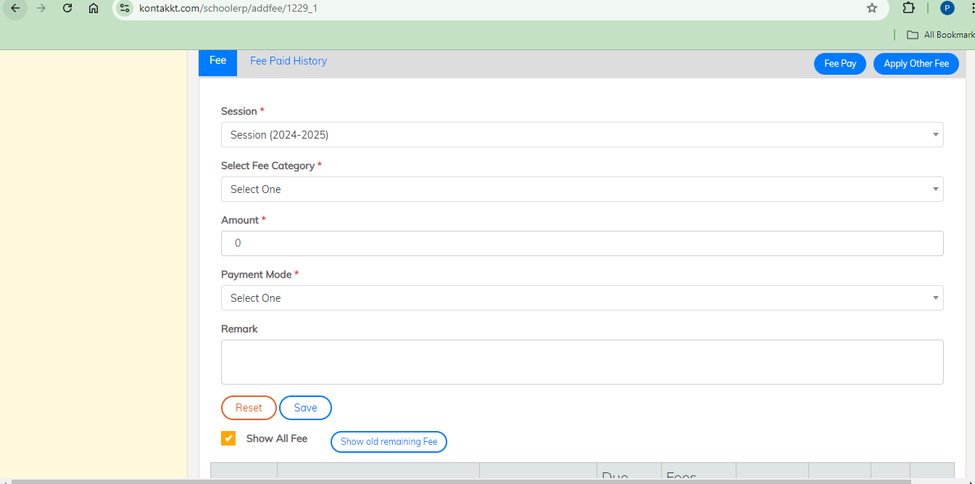

**Q: How do I create message?**

**A: Click on Message Section**

1. Click on the "New Message".
2. Fill the required details.
3. Click on the "Send Message".

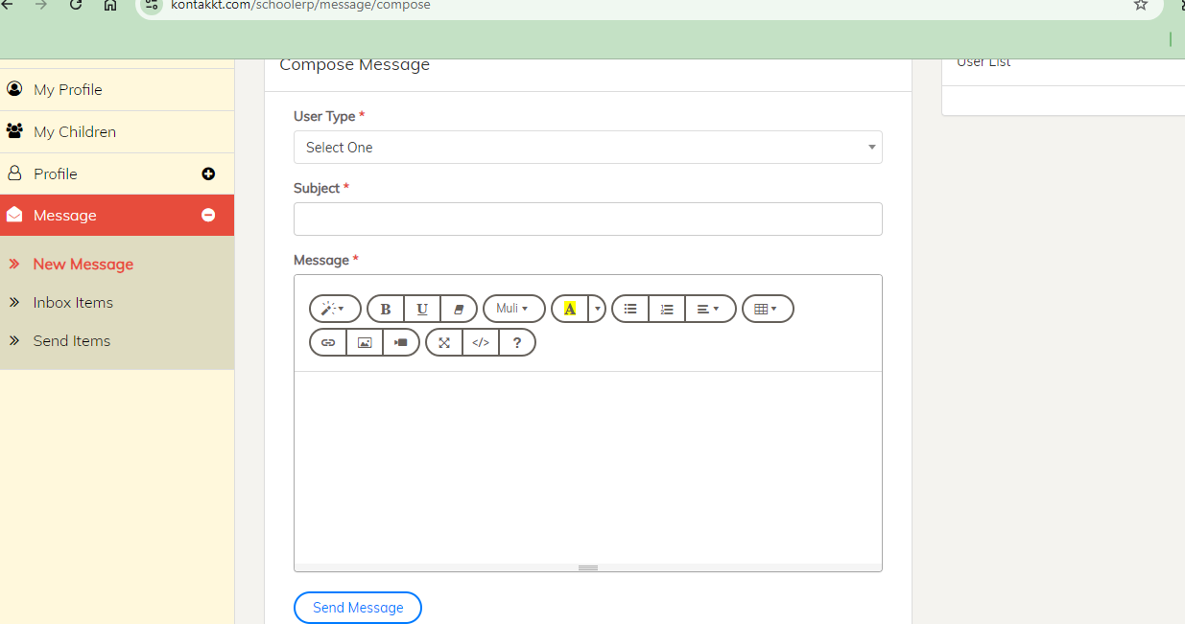

**Q: How do I check my messages?**

**A: Click on Message Section**

1. Click on the "Inbox Items".
2. View messages.

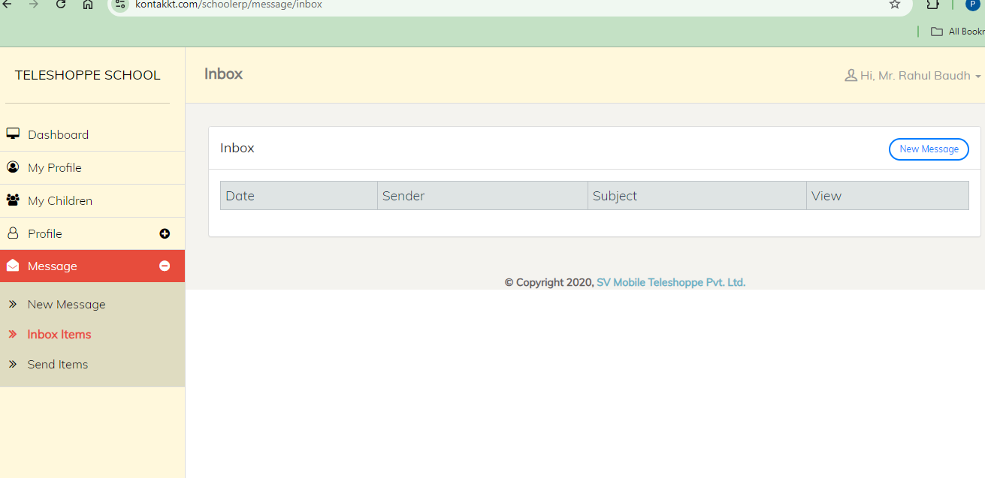

**Getting Help**

**What if I encounter any issues or need assistance?**

If you encounter any issues or need assistance, you can access the help resources by clicking on the "Help" option in the top bar or contacting Kontakkt support.